**Incline Elementary School: 2023-2024**

**Welcome to grade 3!**

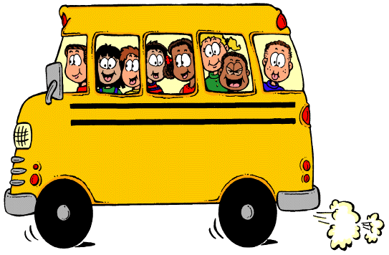

***To Bring to School Every Day***

* Backpack
* Lunch
* Water bottle refillable (optional)

***Classroom Supplies for the First Day of School*** (please don’t put names on supplies, we share everything)

* Earbuds or earphones, either with or without built-in microphone
* Package of 24 #2 pre-sharpened pencils
* 1 box of Kleenex
* Two 2-pocket folders
* One packages Elmer’s glue sticks
* One package Expo dry erase markers
* 1 box of colored pencils

***School Fees***

Here is our school fee structure. Please make checks payable to “Incline Elementary School”:

|  |  |  |
| --- | --- | --- |
| Technology Fee | Provides your student with access to classroom technology | $20 |
| Classroom Fee | Provides your student with additional classroom supplies and activities | $40 |
| **Total Fee\*** |  | **$60** |

* Fees may be waived for families qualifying for Free and Reduced Meal plans. Please come to the main office to complete your FRM forms.

**Have a fantastic school year!**